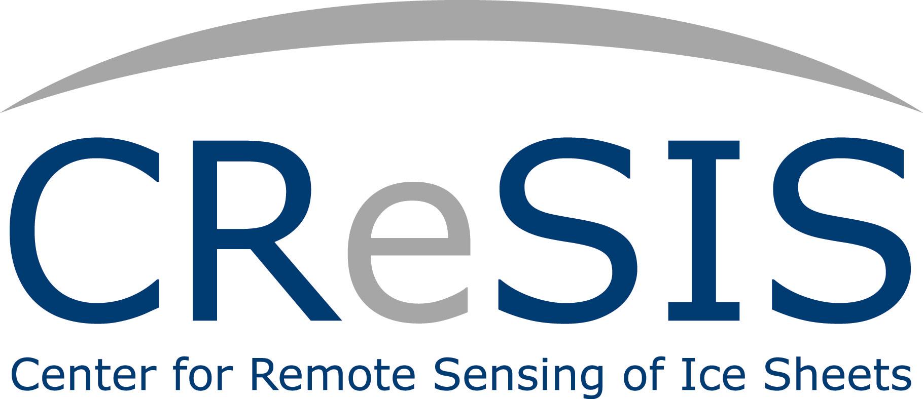

CReSIS Middle School Program
Closing and Luncheon
June 28, 2012 12:00 noon 232 Dixon Hall, ECSU

Welcome Dr. Darnell Johnson, Coordinator

Program Highlights Dr. Darnell Johnson, Coordinator

Student Presentations CReSIS Middle School Researchers

Parent Response TBA

Administrator Response TBA

Surveys Students & Parents

Awards & Comments Dr. Linda B. Hayden, Principal Investigator

Program Staff
Principal Investigator: Dr. Linda Hayden, Director of CERSER,
CReSIS Associate Director

Program Coordinators: Dr. Darnell Johnson,
CReSIS Education Program Manager
Mrs. Wanda Hathaway, ECMS
Climate Change: Mrs. Cheri Hamilton, University of Kansas
GPS/GIS Trainer: Mr. Je’aime Powell, Polar Grid Lab Manager
Hydrology Trainer: Mrs. Wanda Hathaway, ECMS
Physics/Robotics Trainer: URE Math Team
PowerPoint/Camera Trainer: Mr. Jeff Wood, CERSER Webmaster
Undergraduate Student Assistants: REU Summer Math Team Researchers
Administrative Assistants: Mr. Joal Hathaway, Mrs. Marisol Denny,
& Mr. Kevin Jones

“Refreshments”

